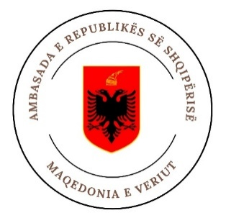




Beyond Borders:

N. Macedonia- Albania Business Forum
Skopje, 12 May 2026
Hotel Alexander Palace (hall К4)

Registration form

скм-зп-ру-10/03

ФОРУМ И БИЛАТЕРЛАНМАКЕДОНИЈА - | Стопанска комора на Северна Ма
Name of the company:
Telephone no.:
Е-mail:
Web:
Company activity / short description and interest in cooperation

Company participants (name, position, contact information)
1.

2.

3.

Please specify which Albanian companies you would like to meet with:
1.
2.
3.
4.
5.

Please confirm your attendance at the event no later than 8 May 2026 (Friday) to:
- MSc. Sanja Nikolova | e-mail: sanja@mchamber.mk | tel.: +389 2 3244-091 | mobile: +389 71 230 452
- Tanja Arbelska-Rafajlovska | e-mail: tanja.arbelska@mchamber.mk | tel.: +389 2 3244-019

